My Dream Island in Humboldt County

By: Jim Graham

13th of September, 2021

# Introduction

Islands provide refuge for many species but can also be threatened by invasive species (Davies 2018). Artificial islands can provide new refuges for species (Bayyinah 2006) but can also cause negative impacts on the environmental (Quinn 1996).

This study creates the design for a new artificial island to be created off the coast of Northern Californian (Figure 1). The island is the intended retirement home for the author.

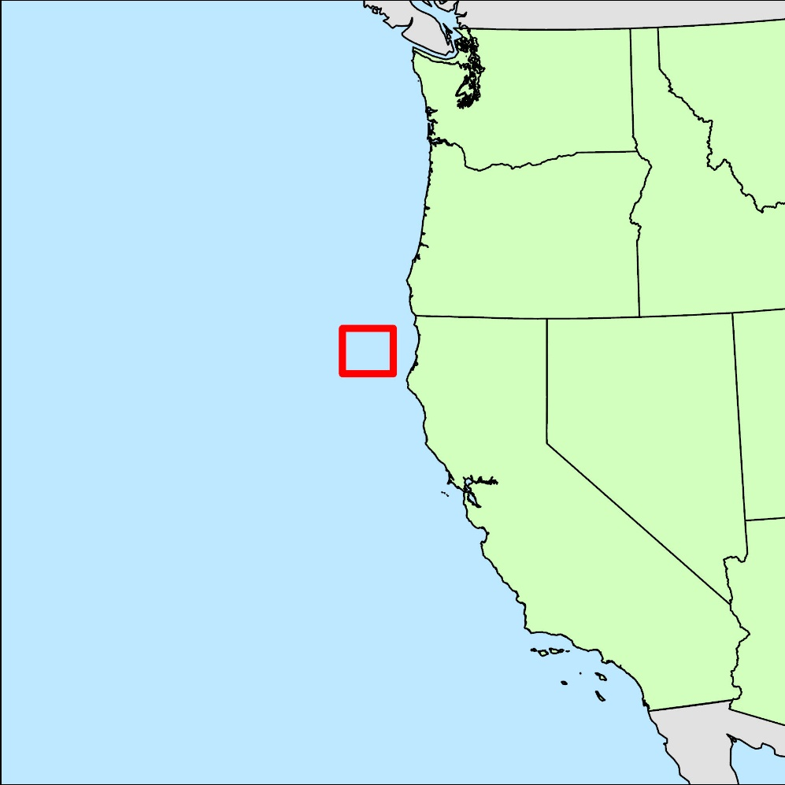

Figure 1 Map showing the location of the island off the cost of Humboldt County within California.

# Methods

Data was downloaded from the Natural Earth website for the background of the locator map (naturalearthdata.com). The island was digitized in ArcGIS Pro version 2.4.0 from Esri, Inc. The background for the island map was added in ArcGIS and attributed to Esri, Maxar, GeoEye, Earthstar Geographics, CNES/Airbus DS, USDA, USGS, AeroGRID, IGN, and the GIS User Community. The final report was prepared in Microsoft Word 2016.

# Results

Our work resulted in two islands with the larger having an area of 100,347 hectares and the smaller being 12,560 hectares.

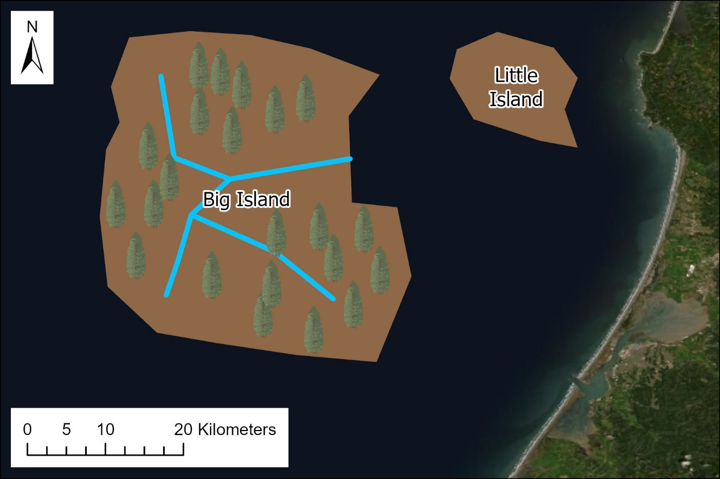

Figure 2 Map of the Big Island and Little Island off the coast of Humboldt County

# Conclusion

This report shows that a large island could be created off the coast of Humboldt County for me to retire at. However, additional work will be needed to determine the cost of the island and the potential environmental impacts.

# Acknowledgements

We acknowledge Natural Earth and Esri for providing access to the data used for the backgrounds in our maps.

## Bibliography

Bayyinah, S. 2006, The Marine Environmental Impacts of Artificial Island Construction Dubai, UAE. Masters’ thesis. Nicholas School of the Environment and Earth Sciences of Duke University.

Davies, H.F., M. A. McCarthy, R. S. C. Firth, J. C. Z. Woinarski, G. R. Gillespie, A. N. Andersen, W. Rioli, J. Puruntatameri, W. Roberts, C. Kerinaiua, V. Kerinauia, K. Brooks Womatakimi, B. P. Murphy. 2018. Declining populations in one of the last refuges for threatened mammal species in northern Australia. Ausstral Ecology. Volume 43. Pages 602-612. Wiley.

Quinn, J.S., R.D. Morris, H. Blokpoel, D.V. Weseloh, and P.J. Ewins. 1996. Design and management of bird nesting habitat: tactics for conserving colonial waterbird biodiversity on artificial islands in Hamilton Harbour, Ontario. Can. J. Fish. Aquat. Sci. 53(Suppl. 1): 45–57.

# Appendix A